**LAB REPORT NO 2**



**CSE-206L Electronic Circuits Lab**

Submitted by:  **Muhammad Ali**

Registration No:- **19PWCSE1801**

Class Section: A

“On my honor, as student of University of Engineering and Technology, I have neither given nor received unauthorized assistance on this academic work.”

Submitted to:

**Engr. Abdullah Hamid**

Data:(30,04,2021)

Department of Computer Systems Engineering

University of Engineering and Technology, Peshawar

**Objectives: -**

* To learn diode functionality in proteus.
* To understand forward bias of diode.
* To understand reverse bias and breakdown region of diode.
* To learn how to plot the graph.

**Component:-**

* Diode
* Dc voltmeter
* Dc ammeter
* Potentiometer
* Voltage source

**Diode: -**

A diode is a semiconductor device that essentially acts as a one-way switch for current. It allows current to flow easily in one direction, but severely restricts current from flowing in the opposite direction.

**Forward bias: -**

This bias condition incorporates the connecting of a positive voltage potential to the P-type material and a negative to the N-type material across the diode, thus decreasing the width of the diode. ... Zero Bias: This is a bias condition in which there is no external voltage potential applied to the diode.

**Reverse bias: -**

Reverse bias usually refers to how a diode is used in a circuit. If a diode is reverse biased, the voltage at the cathode is higher than that at the anode. Therefore, no current will flow until the electric field is so high that the diode breaks down.

Because the p-type material is now connected to the negative side of the applied voltage, the holes in the p-type material are pulled away from the junction, causing the thickness of the depletion layer to increase.

By applying a negative voltage (reverse bias) results in the free charges being pulled away from the junction resulting in the depletion layer width being increased.

**Potentiometer: -**

A potentiometer (also known as a pot or potmeter) is defined as a 3 terminal variable resistor in which the resistance is manually varied to control the flow of electric current. A potentiometer acts as an adjustable voltage divider.

we can use a voltage divider with one of the resistors being a potentiometer to create a lower voltage, the problem is that your voltage out will depend on both the voltage in as well as the load of the output (ie, what our voltage regulator is powering).

Potentiometers are commonly used to control electrical devices such as volume controls on audio equipment. Potentiometers operated by a mechanism can be used as position transducers.

**Experimental steps: -**

1). we Connect the diode in the forward bias mode.

2). Connect a current limiting resistor in series with the diode.

3). Connect potentiometer across voltage source.

4). Then we connect dc ammeter with diode and dc voltmeter across diode.

5). Slowly increase the voltage applied, and measure the current (I) through the diode and the voltage across the diode (VD). Take more than 10 readings.

6). we note the measure values of current with dc ammeter voltage across dc voltmeter

7). And plot the graph EXCEL sheet consisting all measured values.

8). We repeat all steps for reverse bias by slip the diode and increase voltage to 200V.

**Forward bias: -**

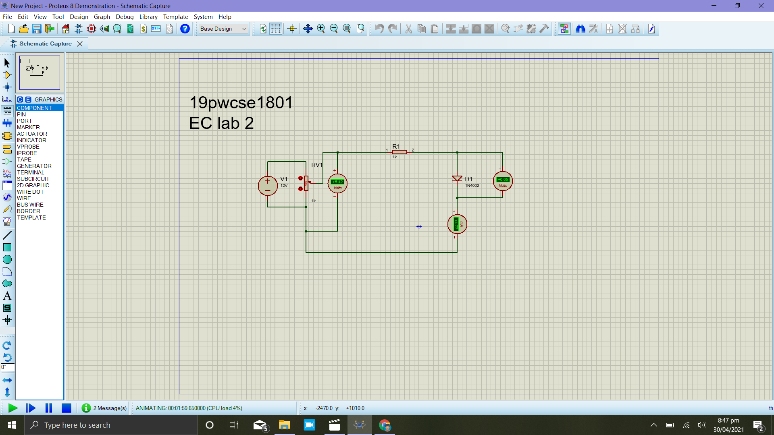

**Graph: -**

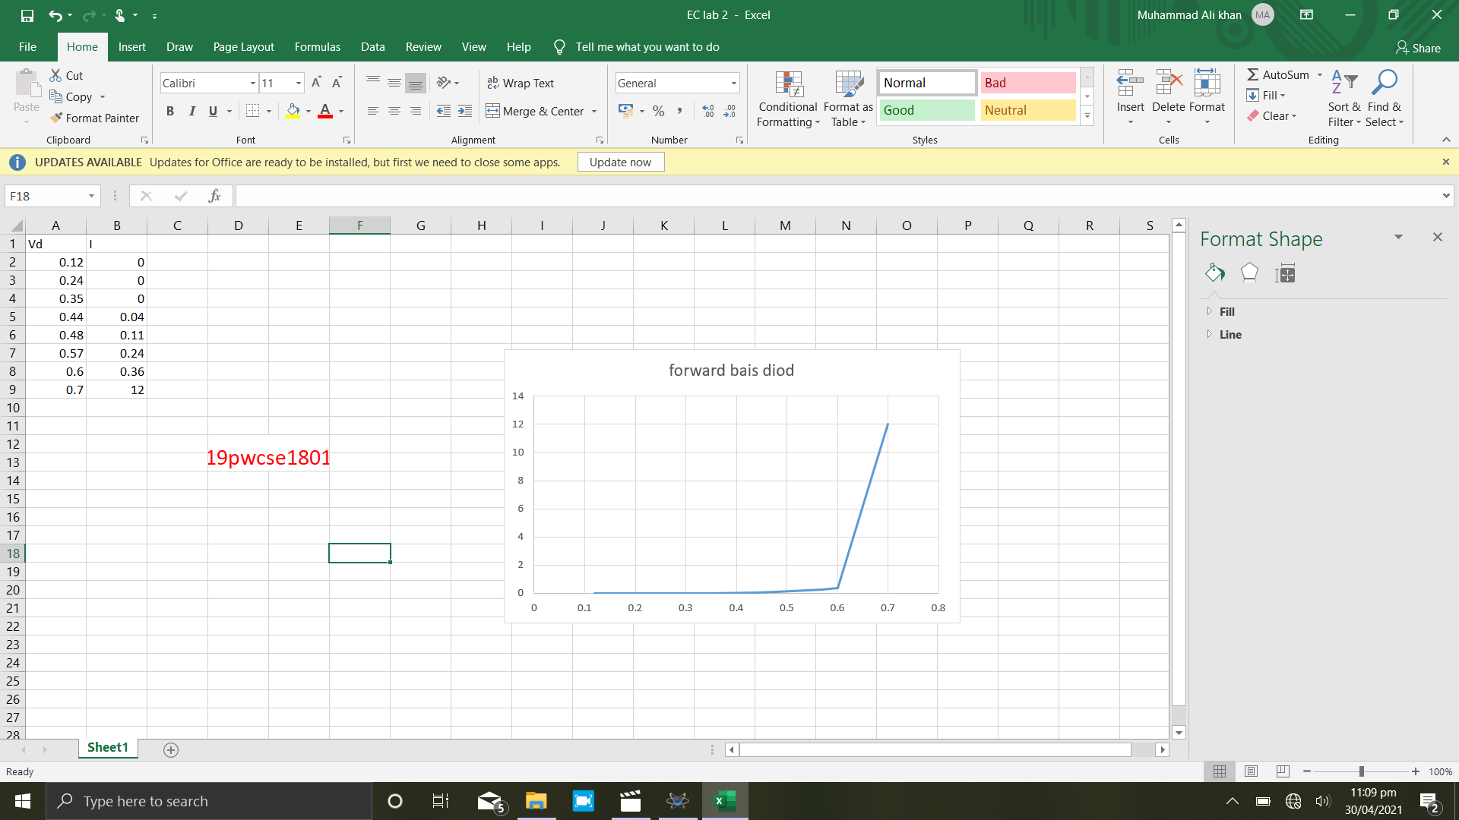

**Reverse bais:-**

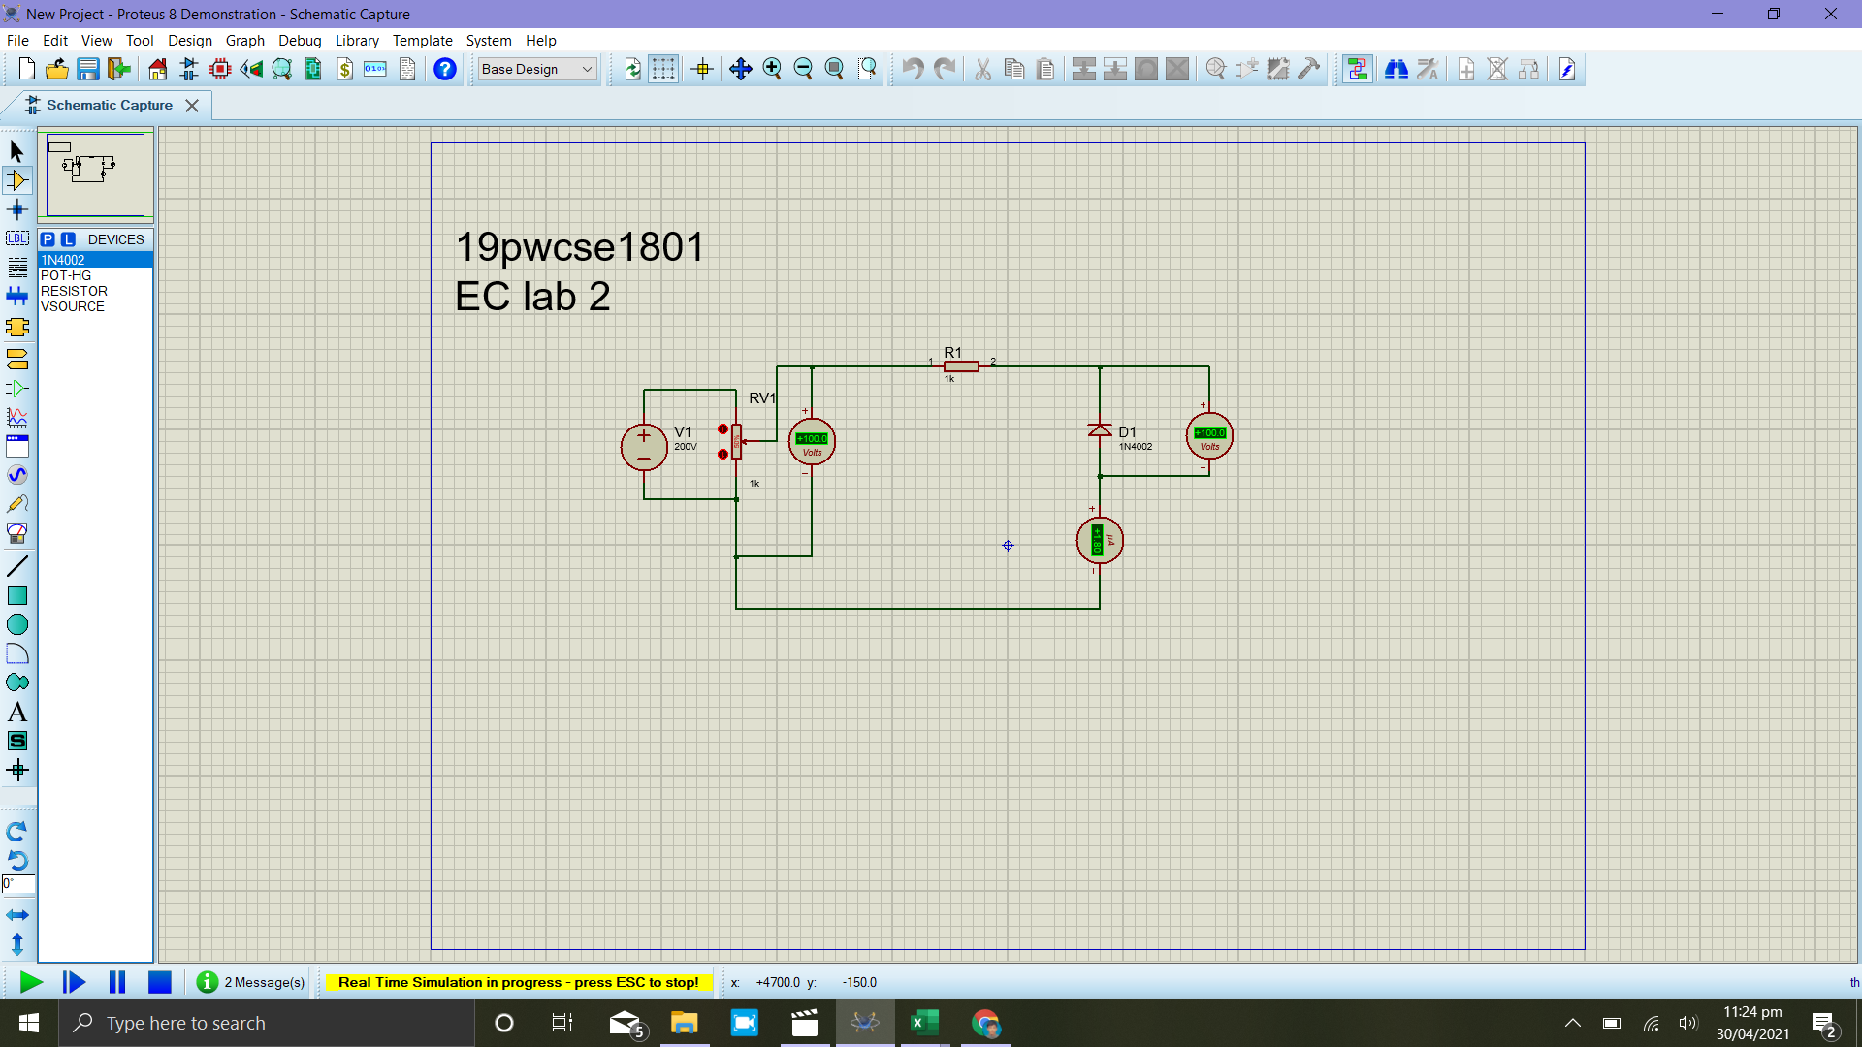

**Graph: -**

